ARTICLE TITLE

First author's name, surname¹, Second author's name, surname ²
¹Institution represented by the author of the article, address
²Institution represented by the author of the article, address

Abstract

Abstract of the article in the original language (up to 500 words). This is a concise text that presents the essence of the article, presenting the purpose of the study, its rationale, applied research methods, and the most important conclusions and/or new questions raised.
Keywords: 4-7 meaningful words are given, separated by commas.

Introduction

The introduction substantiates the relevance and novelty of the topic, defines the research goal, object, scientific or research problem, the degree of the research, applied research methods.

1. Chapter title

The body text of the article describes and substantiates the results of the author's research. An up-to-date review of the scientific literature related to the problem addressed in the article is presented. The journal Insights uses the APA (American Psychological Association) citation style. In the text, the name of the author(s) and the year of the publication should be indicated in brackets. When citing a source of one author in the text it is written as follows: (Surname, 2020). When citing a source of two authors in the text it is written as follows: (Surname1 and Surname2, 2018) or (Surname1 & Surname2, 2018). If three or more authors are cited, only the first author is given in the text, e.g. (Surname et al., 2017). If a specific part of the source is cited or an exact quote is provided, the reference also includes the page number, e.g. (Surname et al., 2017, p. 85). If the works of different authors with the same last name are cited, the authors' initials are also included in the references, e.g. (N. Surname, 2018; M. Surname, 2019). Using different sources of the same author, published in the same year, it is cited as follows: (Surname, 2018a; Surname, 2019b). Accordingly, these letters must be added to the year of publication and provided in the reference list.
If the author of the publication is an institution, association, etc., the citation should be written as follows: (Utena University of Applied Sciences [UUAS], 2020) [first citation]; (UUAS, 2021) [second and subsequent references]. If the author is not indicated in the publication, the title and the year of publication are written as follows: (Digital Economy and Society in Lithuania, 2022) or the first words of the title of the work (Motor Vehicles, 2016).

2. Chapter title

An article prepared for the journal Insights must meet the following requirements:
- The volume of the article is 5–14 pages;
- The text of the article is printed using the Microsoft Word editor, in 12 pt Times New Roman font;
- The manuscript is laid out on a 21 centimeters wide and 29.7 centimeters high format sheet in one column, single-line spacing (single) with 2 cm margins, using double-sided alignment;
- Paragraphs begin with an indent of 0.7 cm;
- Between the title of the article and the author's name and surname, the title of the chapter and the text, the text and the formula, the text and the table, the text and the figure, a one-line interval is left;
- Text style fonts and sizes used for parts of the article manuscript are listed in Table 1.

Table 1. Text style fonts and sizes used for the manuscript parts of the article
Text style fonts and sizes used for the manuscript parts of the article | Text font size, style | Text font sizes, alignment requirements
Title | 12 pt, Bold | Capital letters, aligned to the left margin
Author and supervisor | 12 pt, Bold | Lowercase letters, aligned to the left margin
Name, department, address of the scientific and study institution represented by the author | 11 pt, Italic | Lowercase letters, aligned to the left margin
Abstract | 12 pt, Bold | Lowercase letters, aligned to the left margin
Abstract text | 12 pt, Normal | Lowercase letters, aligned to the left margin
Introduction, titles of chapters | 12 pt, Bold | Lowercase letters, aligned to the left margin
Body text | 12 pt, Normal | Lowercase letters, alignment on both sides
Summary | 11 pt, Normal | Lowercase letters, alignment on both sides
Reference list | 11 pt, Normal | Alignment on both sides, sources are numbered
Mathematical expressions: basic symbols, indices | 11 pt, Italic  9 pt, Italic | One indent from the left margin
Titles of tables | 11 pt, Bold | Centered, above the table. First, the number of the table, full stop, and title of the table
Table text | 11 pt. Normal | Lowercase letters, aligned to the left margin or across the page
Titles of figures | 11 pt, Bold | Centered, below the image. First, the picture number, full stop, and the title of the picture

- The tables are laid out together with the text, the alignment is mutual, they are numbered above the tables in continuous order with Arabic numerals, the source is indicated.
- Figure - picture, diagram or scheme is centered in the text. Titles are written below the figure in the center, numbered consecutively, and the source is indicated. All pictures must be clear (Figure 1).

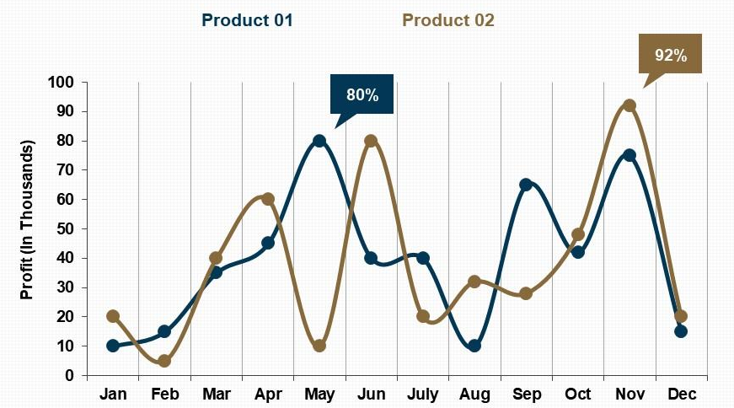
Figure 1. Title of the figure
Source: made by the authors

- Mathematical expressions (formulas) are printed only in the Microsoft Equation editor in Italic Times New Roman font. Symbols from formulas mentioned in the text are printed only in the Microsoft Equation editor. Formulas are numbered consecutively with Arabic numerals in brackets to the right of the formula, e.g.:

$v_{st}=\frac{2·S·n}{60},$ (1)

here: S - stroke of the piston, m; n – motor shaft rotation speed, min⁻¹.

Conclusions

1. Conclusions summarize the considerations presented in the article and the results of research. It is preferable that the conclusions are numbered.
2. Conclusions and recommendations should correspond to the objectives raised in the article.

Funding information and/or acknowledgment (if applicable)

At the end of the article, information about the funding received for the preparation of scientific work can be provided. Acknowledgments may also be given to individuals who contributed to the preparation of the article.

Reference list

- A detailed list of references is provided at the end of the article, with the names of the first authors arranged according to the Latin alphabet, and if there are none, according to the first letter of the publication. References written in non-Latin characters are listed at the end of the list. If several publications of the same author published in the same year are indicated, they should be distinguished by adding the letters a, b, c..., after the year of publication. Examples of creating a reference list:
- Keskin, A., Guru, M. and Altiparmak, D. (2007). Biodiesel Production From Tall Oil with Synthesized Mn and Ni Based Additives: Effects of the Additives on Fuel Consumption and Emissions, Fuel 86 (7), 1139-1143. doi.org/10.1016/j.fuel.2006.10.021. (Article in a scientific journal).
- Paliulis, N., Chlivickas, E. and Pabedinskaitė, A. (2014). Management and Information. Vilnius: Technology (Book).
- Valiulis, A. V. (2013). Engineering Materials Science: Structure, Properties and Applications. doi: 10.3846/1473-S. Available online: < https://www.ebooks.vgtu.lt/product/engineering-materials-science-structure-properties-applications >. (E-book).
- Vares, V., Kask, U., Muiste, P., Pihu, T. and Soosaar, S. (2007). Biofuel user manual. Access via the Internet: <http://enmin.lrv.lt/lt/veiklos-sritys-3/atsinaujinanyts-energijos-istekliai/tyrimai-ir-analizes-3>. (Web page).

More information on citation and bibliography: https://www.mendeley.com/guides/apa-citation-guide.

THE TITLE OF THE ARTICLE IN A FOREIGN LANGUAGE

First author's name, surname¹, Second author's name, surname²
¹The institution represented by the author of the article
²The institution represented by the author of the article

Summary

Summary of the article (up to 1 page, i.e. about 3000 characters) in English (if the article is written in Lithuanian) or in Lithuanian. The abstract should outline the main points and conclusions of the article.
Keywords: the first keyword, the second keyword, the third keyword.

